**NUNIT NOTES**

**REQUIREMENTS**

1. NUnit NuGet package
   1. Instructions below
2. NUnit 3 Test Adapter
   1. Documentation [here](http://www.alteridem.net/2016/10/20/nunit-visual-studio-adapter/)
   2. Not exactly a requirement, but eases using NUnit – can run tests through Visual Studio’s test explorer (otherwise you would have to use NUnit’s console which I’ve heard is not great)

**Install NUnit NuGet Package**

1. In Visual Studio open the desired solution. In the solution explorer, right click References > Manage NuGet Packages…

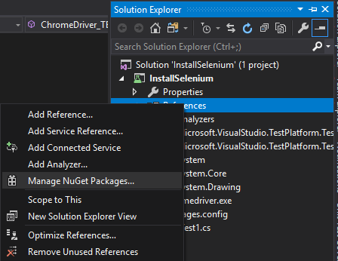

1. Switch to the “Browse” tab
2. Search: ‘NUnit’

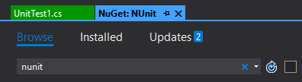

1. Install [NUnit](https://www.nuget.org/packages/nunit/)

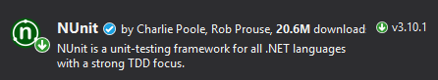

1. In the Changes dialog, click OK:

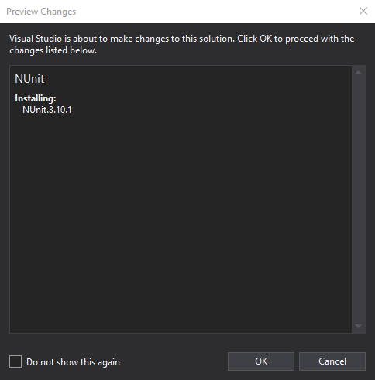

1. Verify that the install succeeded:

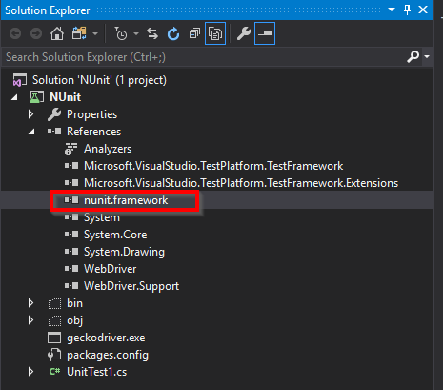

1. Build Solution

**NUnit Test Example**

Create Setup and Teardown attributes.

***Setup*** – called immediately before any test is run

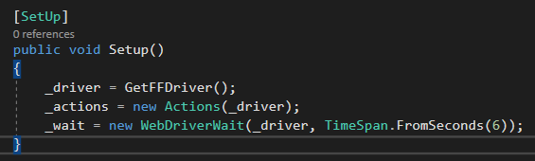

***Teardown*** – guaranteed to be called after each test is run, even if an exception is thrown

